Spectral clustering

1. an image with connected circles is generated and spectral clustering is used to separate the circles.
2. the [Spectral clustering](https://scikit-learn.org/stable/modules/clustering.html#spectral-clustering) approach solves the problem know as ‘normalized graph cuts.
3. the image is seen as a graph of connected voxels, and the spectral clustering algorithm amounts to choosing graph cuts defining regions while minimizing the ratio of the gradient along the cut, and the volume of the region.
4. As the algorithm tries to balance the volume ( balance the region sizes), if we take circles with different sizes, the segmentation fails.
5. In addition, as there is no useful information in the intensity of the image, or its gradient, we choose to perform the spectral clustering on a graph that is only weakly informed by the gradient.
6. This is close to performing a Voronoi partition of the graph.

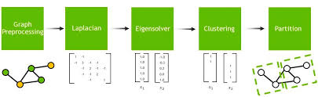

Assign each data point to the cluster determined by the clustering algorithm applied in the previous step.

Spectral clustering is particularly effective when dealing with non-convex or irregularly shaped clusters. By working in a transformed space defined by the eigenvectors, spectral clustering can capture complex structures in the data.

The choice of parameters, such as the number of clusters (K) and the type of affinity matrix, can significantly impact the performance of spectral clustering. It is essential to experiment and tune these parameters based on the characteristics of the data.

Overall, spectral clustering is a powerful technique for unsupervised learning and has found applications in various fields, including image segmentation, community detection in social networks, and gene expression analysis.